

# At Zara Therapy Clinic

|  |  |  |
| --- | --- | --- |
| **Supervisor:** | *LÊ THANH NHÂN* |  |
| **Semester:** | *I* |  |
| **Batch No:** | *T1.2209.M0* |  |
| **Group No:** | *05* |  |
| **Order:** | **Full name** | **Roll No.** |
| *1.* | *Nguyễn Thành Trung* | *Student1416054* |
| *2.* | *Nguyễn Hoàng Thiên Ân* | *Student1421297* |
| *3.* | *Nguyễn Hữu Duy Khang* | *Student1420700* |
| *4.* | *Nguyễn Nam Khánh* | *Student1420718* |

***Month****: 12* ***Year****: 2022*

This is to certify that



|  |  |
| --- | --- |
| **Mr.** | **Nguyễn Thành Trung** |
| **Mr.** | **Nguyễn Hoàng Thiên Ân** |
| **Mr.** | **Nguyễn Hữu Duy Khang** |
| **Mr.** | **Nguyễn Nam Khánh** |

Have successfully Designed & Developed

# At Zara Therapy Clinic

Submitted by:

**Mr. LE THANH NHAN**

Date Of Issue:

Authorized Signature:

**Content**

Content Acknowledge Synposis

Review1 (điền số trang theo thực tế)

Review2 (điền số trang theo thực tế)

Review3 (điền số trang theo thực tế)

Testting Document (điền số trang theo thực

tế)

Final Checklist (điền số trang theo thực tế)

Tasksheet (điền số trang theo thực

tế)

# Acknowledge

As we know eproject is an enviroment that simulates like a class room or lab.It’s a projection at your fingertips.Live on the machine which allows you to :

* Practice step by step i.e. laddered approach.
* Build a larger more robust application.
* Usage of certain utilities in applications designed by user.
* Single program to unified code leading to a complete application.
* Learn implementation of concepts in a phased manner.
* Enhance skills and add value.
* Work on real life projects.
* Give a real life scenario and help to create applications more complicated and useful.
* Mentoring through email support.

We would like to send a great thank to our professor and others student for the addorable supports during the time in project.

And beside the mistakes we’ve made in the project we hope to widen our knowledge for the developing world.

With that said today we as group 5 are going to present our eproject to you. The aim of our project is about health,therapy for people who need it.

We also thank you so much for your infomation and the “demo” project from India APTECH to help us get more reality experience in this project. Since we have gained more experience from this project, we will not stop learning any thing as much as we can to be more successful in the future.

Your Sincerely, Team Group 05.

# Synposis

The object we have is to create a sample project for real life work projects. For those to give us help for larger projects.

the problem

Ten million surgical procedures take place in the UK per year, with cancellation rates at around 20%. Currently hospitals use non-standardised paper based preoperative assessments, conducted by clinical staff during a 45-minute hospital visit, which can extend upwards of 3 hours for some patients. This is a resource intensive process often completed too close to the surgical procedure to reallocate resources should a cancellation occur.

The solution

Synopsis Healthcare provides a more efficient process of preoperative assessments using an online assessment questionnaire. This allows hospitals to focus staff resources more effectively in managing theatre throughput, and allows up 40% of low risk patient to avoid having to attend a full pre-operative clinic. Resources can then be better focused on higher- risk patients. Synopsis helps reduce surgery cancellations, improve efficiency and productivity, better manage patient safety risk, improve patient experience, and increase revenue reimbursement.

Total Benefits of £65 million could be realised from:

* Efficiency of collecting pre-operative data
* Reduced cancellations (current cancellation rate is ~20%)
* Active customer Southend University Hospital, Essex, reduced pre-assessment process from 44% costs down to 31% running costs, saving the small unit £80,000 a year.

|  |  |  |
| --- | --- | --- |
| **Design Plan**:  At Zara Therapy Clinic | **Document Name**: Problem Definition | **SWD/Form** No.01/PD/Ver1.0 |
| **Effective Date**:07-012-2022 | **Version** 1.0 | **Page No**: 4 of **17** |

## Problem Definition

* 1. Medical physics is a branch of applied physics that utilizes physical sciences to prevent, diagnose, and treat human diseases. Medical physics can be categorized into multiple sub-groups: medical imaging physics, radiation oncology physics, non-ionizing medical radiation physics, nuclear medicine physics, medical health physics, and physiological measurements.

Medical physics primarily focuses on ionizing radiation measurement, magnetic resonance imaging, and applying physics-based technologies (lasers and ultrasound) in medicine.

The term "medical physics" was first introduced by Félix Vicq d'Azir, a French physician, anatomist, and the general secretary of the Royal Society of Medicine, in Paris in 1778. In 1814, the most appropriate definition of medical physics was introduced in the revised edition of Nysten's medical dictionary. In this edition, medical physics was defined as *"physics applied to the knowledge of the human body, to its preservation and to the cure of its illnesses."*

* 1. Medical physicists are healthcare professionals who have specialized training in applying physics concepts and technologies in medicine. They primarily work in clinical setups or in academic and research institutions. The key roles and responsibilities of medical physicists include the application of medical physics techniques for the diagnosis and treatment of human diseases and the protection of medical staff and patients from ionizing and non-ionizing radiation hazards.

Medical physicists specialized in radiation therapy are primarily involved in providing radiation treatments for cancer patients in collaboration with oncologists and other therapists. The treatments mostly include brachytherapy, wherein a radiation source is placed inside the body, or external beam radiation therapy, wherein linear accelerator-generated radiation is carefully delivered to affected tissues.

|  |  |  |
| --- | --- | --- |
|  | **Prepared by (Student)** | **Approved by (Faculty)** |
|  | **Project Group No**: 05 | Le Thanh Nhan |
| **Signature** |  |  |
| **Date** |  |  |

|  |  |  |
| --- | --- | --- |
| **Design Plan**:  At Zara Therapy Clinic | **Document Name**:  Customer Requirements Specifications | **SWD/Form** No.02/CRS/Ver1.0 |
| **Effective Date**:7-12-2022 | **Version** 1.0 | **Page No**: 5 of **20** |

Medical physicists specializing in medical imaging are engaged in developing and maintaining various imaging techniques, including x-ray, computed tomography scan (CT-scan), and magnetic resonance imaging.

Medical physicists specialized in nuclear physics mostly conduct functional imaging of patients using positron emission tomography (PET), gamma camera, and biological substances labeled with radioactive markers (radiopharmaceuticals).

* 1. the problems
* bones, joints and soft tissue – such as [back pain](https://www.nhs.uk/conditions/back-pain/), [neck pain](https://www.nhs.uk/conditions/neck-pain-and-stiff-neck/), [shoulder pain](https://www.nhs.uk/conditions/shoulder-pain/) and [sports injuries](https://www.nhs.uk/conditions/sports-injuries/), sprains,broken arms and legs
* brain or nervous system – such as movement problems resulting from a [stroke](https://www.nhs.uk/conditions/stroke/), [multiple sclerosis (MS)](https://www.nhs.uk/conditions/multiple-sclerosis/) or [Parkinson's disease,](https://www.nhs.uk/conditions/parkinsons-disease/)brain infarction disease
* heart and circulation – such as rehabilitation after a [heart attack](https://www.nhs.uk/conditions/heart-attack/)
* lungs and breathing – such as [chronic obstructive pulmonary disease (COPD)](https://www.nhs.uk/conditions/chronic-obstructive-pulmonary-disease-copd/) and [cystic fibrosis](https://www.nhs.uk/conditions/cystic-fibrosis/),covid-19
* education and advice – physiotherapists can give general advice about things that can affect your daily lives, such as posture and correct lifting or carrying techniques to help prevent injuries
* movement, tailored exercise and physical activity advice – exercises may be recommended to improve your general health and mobility, and to strengthen specific parts of your body
* manual therapy – where the physiotherapist uses their hands to help relieve pain and stiffness, and to encourage better movement of the body
* Preventable Medical Errors Customers can
* send a feedback for us to be better.
* look into more problems with healthcare.
* aply for membership for additional benifits.

|  |  |  |
| --- | --- | --- |
| **Design Plan**:  At Zara Therapy Clinic | **Document Name**:  Customer Requirements Specifications | **SWD/Form** No.02/CRS/Ver1.0 |
| **Effective Date**:7-12-2022 | **Version** 1.0 | **Page No**: 5 of **20** |

## Customer Requirements Specifications

### User:

**input:**

- Customer registration data

- Customer detail to choose

- Inform customers need advice

- Suggestions for staff

Process:

- Find disease detail

- Find detail about medical examination services

- Search for an appointment with a doctor

- Search for therapeutic tools

- Check member registration detail

- Check the comment detail

Output:

- Notification of successful/failed registration

- Details about the selected examination service

- Details about the disease

|  |  |  |
| --- | --- | --- |
| **Design Plan**:  At Zara Therapy Clinic | **Document Name**:  Customer Requirements Specifications | **SWD/Form** No.02/CRS/Ver1.0 |
| **Effective Date**:7-12-2022 | **Version** 1.0 | **Page No**: 5 of **20** |

- Details about therapeutic instruments

- Details about appointments with doctors

- Notice of success/failure suggestions

### Webmaster:

**input:**

* Login with admin detail
* Service detail to make an appointment with a doctor
* Detail about treatments to add/edit/delete
* Detail about therapists to add/edit/delete
  + Detail about physiotherapists Add/edit/delete
  + Respond to employee comments

### Process:

* + Add/edit/delete disease detail
  + Add/edit/delete medical services
  + Add/edit/delete treatments
  + Add/edit/delete therapeutic medical devices

|  |  |  |
| --- | --- | --- |
| **Design Plan**:  At Zara Therapy Clinic | **Document Name**:  Customer Requirements Specifications | **SWD/Form** No.02/CRS/Ver1.0 |
| **Effective Date**:7-12-2022 | **Version** 1.0 | **Page No**: 5 of **20** |

* + Add/edit/delete doctor's information
  + Remove member
  + Check feedback information
  + Delete comments

### Output:

* + Notification of login success/failure
  + Announcement of adding/editing/deleting successful/failure disease

information

* Notification of adding/editing/deleting successful/failure doctor information
  + Notification of successful/failed adding/editing/deleting medical devices
  + Notice of successful/failed member deletion
  + Notification of successful/failed feedback response
  + Notice of successful/failed comment deletion

### Hardware / software requirement:

**Software:**

Sever:

* + - Pentium 4, 1.8 Ghz or better
    - 512 MB of RAM

|  |  |  |
| --- | --- | --- |
| **Design Plan**:  At Zara Therapy Clinic | **Document Name**:  Customer Requirements Specifications | **SWD/Form** No.02/CRS/Ver1.0 |
| **Effective Date**:7-12-2022 | **Version** 1.0 | **Page No**: 5 of **20** |

* + - 300MB of HDD capacities available Client:
    - Pentium III, 500 Mhz
    - 256 MB of RAM

### Hardware:

Sever:

* + OS with Windows XP SP2
  + IE 5.0/Netscape 6.0
  + SQL Sever 2008
  + Dreamweaver MX 2004
  + Internet Information Services (IIS)

Client:

* + IE 5.0/Netscape 6.0
  + Flash player 8

|  |  |  |
| --- | --- | --- |
| **Design Plan**:  At Zara Therapy Clinic | **Document Name**:  Architecture and design of the project | **SWD/Form** No.03/ARD/Ver1.0 |
| **Effective Date**:07-012-2002 | **Version** 1.0 | **Page No**: **5** of **17** |

## Architecture and design of the project

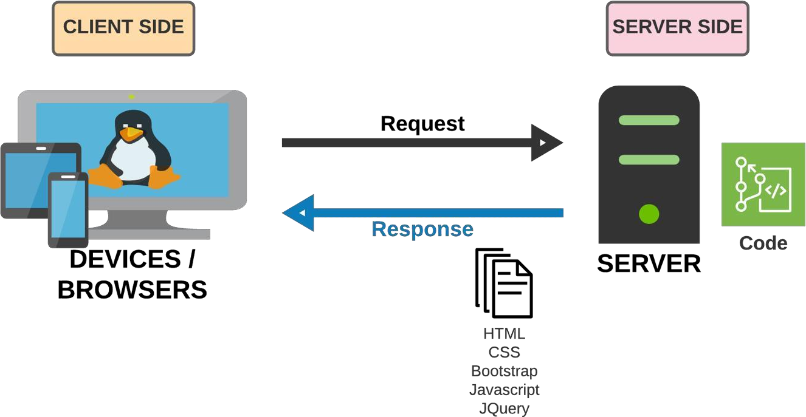

|  |  |  |
| --- | --- | --- |
| **Design Plan**:  At Zara Therapy Clinic | **Document Name**: SiteMap | **SWD/Form** No.04/SM/Ver1.0 |
| **Effective Date**:07-12-2022 | **Version** 1.0 | **Page No**: **6** of **17** |

Social Media

Address,

Phone number

Membership

Message

Blog

**SiteMap**

Register

Feedback

About Us

Contact Us

Book

Functional

foods

Acupuncture

Massage Therapy

Physical Therapy

Service

Login

Homepage

|  |  |  |
| --- | --- | --- |
| **Design Plan**:  At Zara Therapy Clinic | **Document Name**: Screen shots | **SWD/Form** No.05/SS/Ver1.0 |
| **Effective Date**:07-12-2022 | **Version** 1.0 | **Page No**: **7** of **17** |

## Screen shots

**Ví dụ cách thứ nhất:** (Khuyến cáo sử dụng) **I. Homepage:** 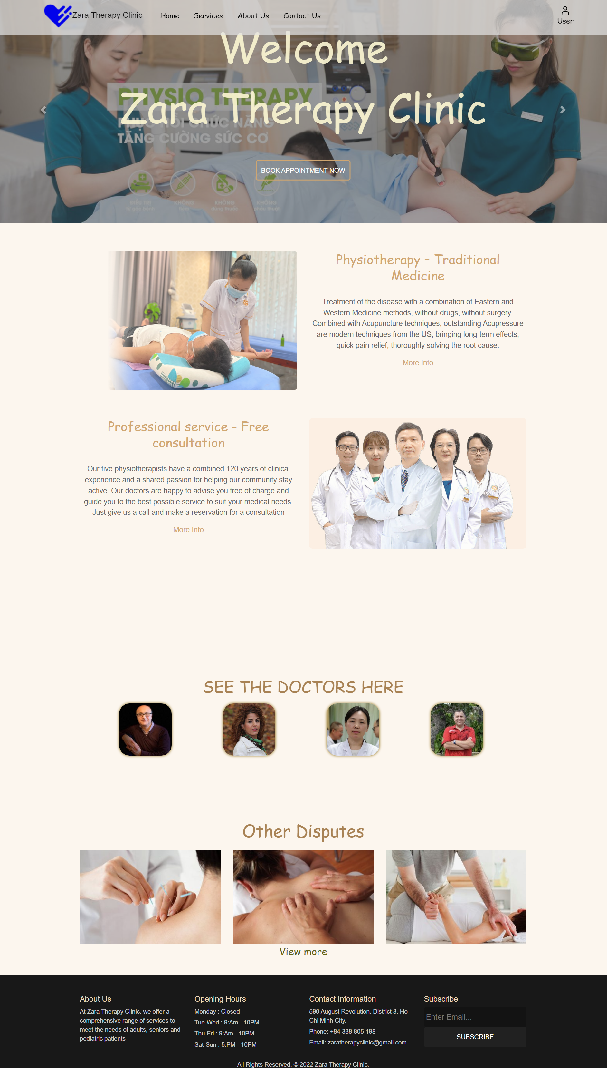

**Description** : Home User Navigation,Used to navigate small menus

**From** : Home page

**To** : Service,Contact Us,About Us,Login

|  |  |  |
| --- | --- | --- |
| **Design Plan**:  At Zara Therapy Clinic | **Document Name**: Screen shots | **SWD/Form** No.05/SS/Ver1.0 |
| **Effective Date**:07-12-2022 | **Version** 1.0 | **Page No**: **8** of **17** |

### Ví dụ cách thứ hai:

**I. Service:**

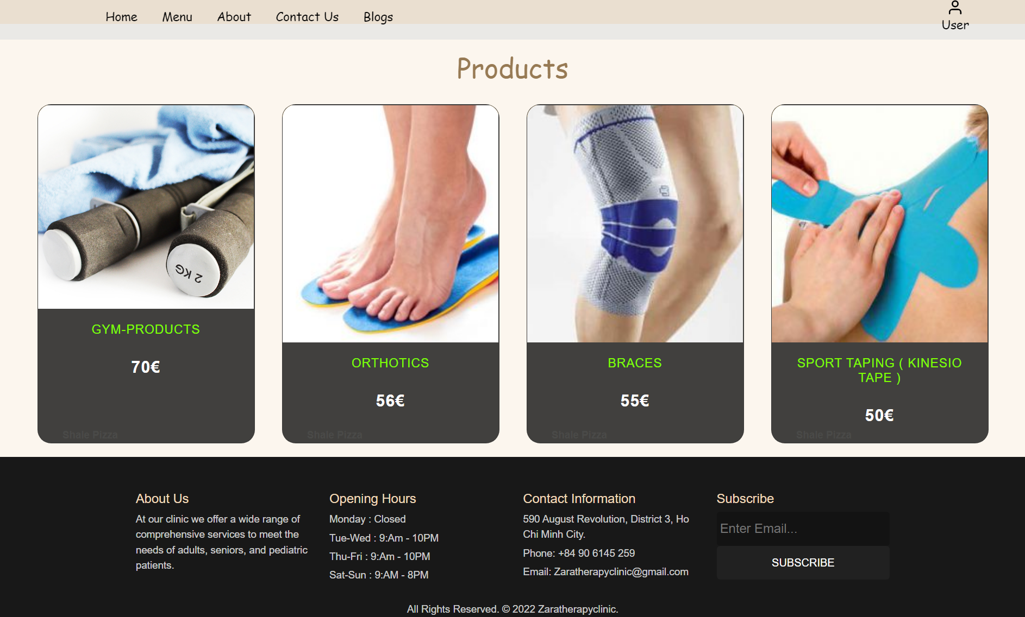

**II: Aboutus** 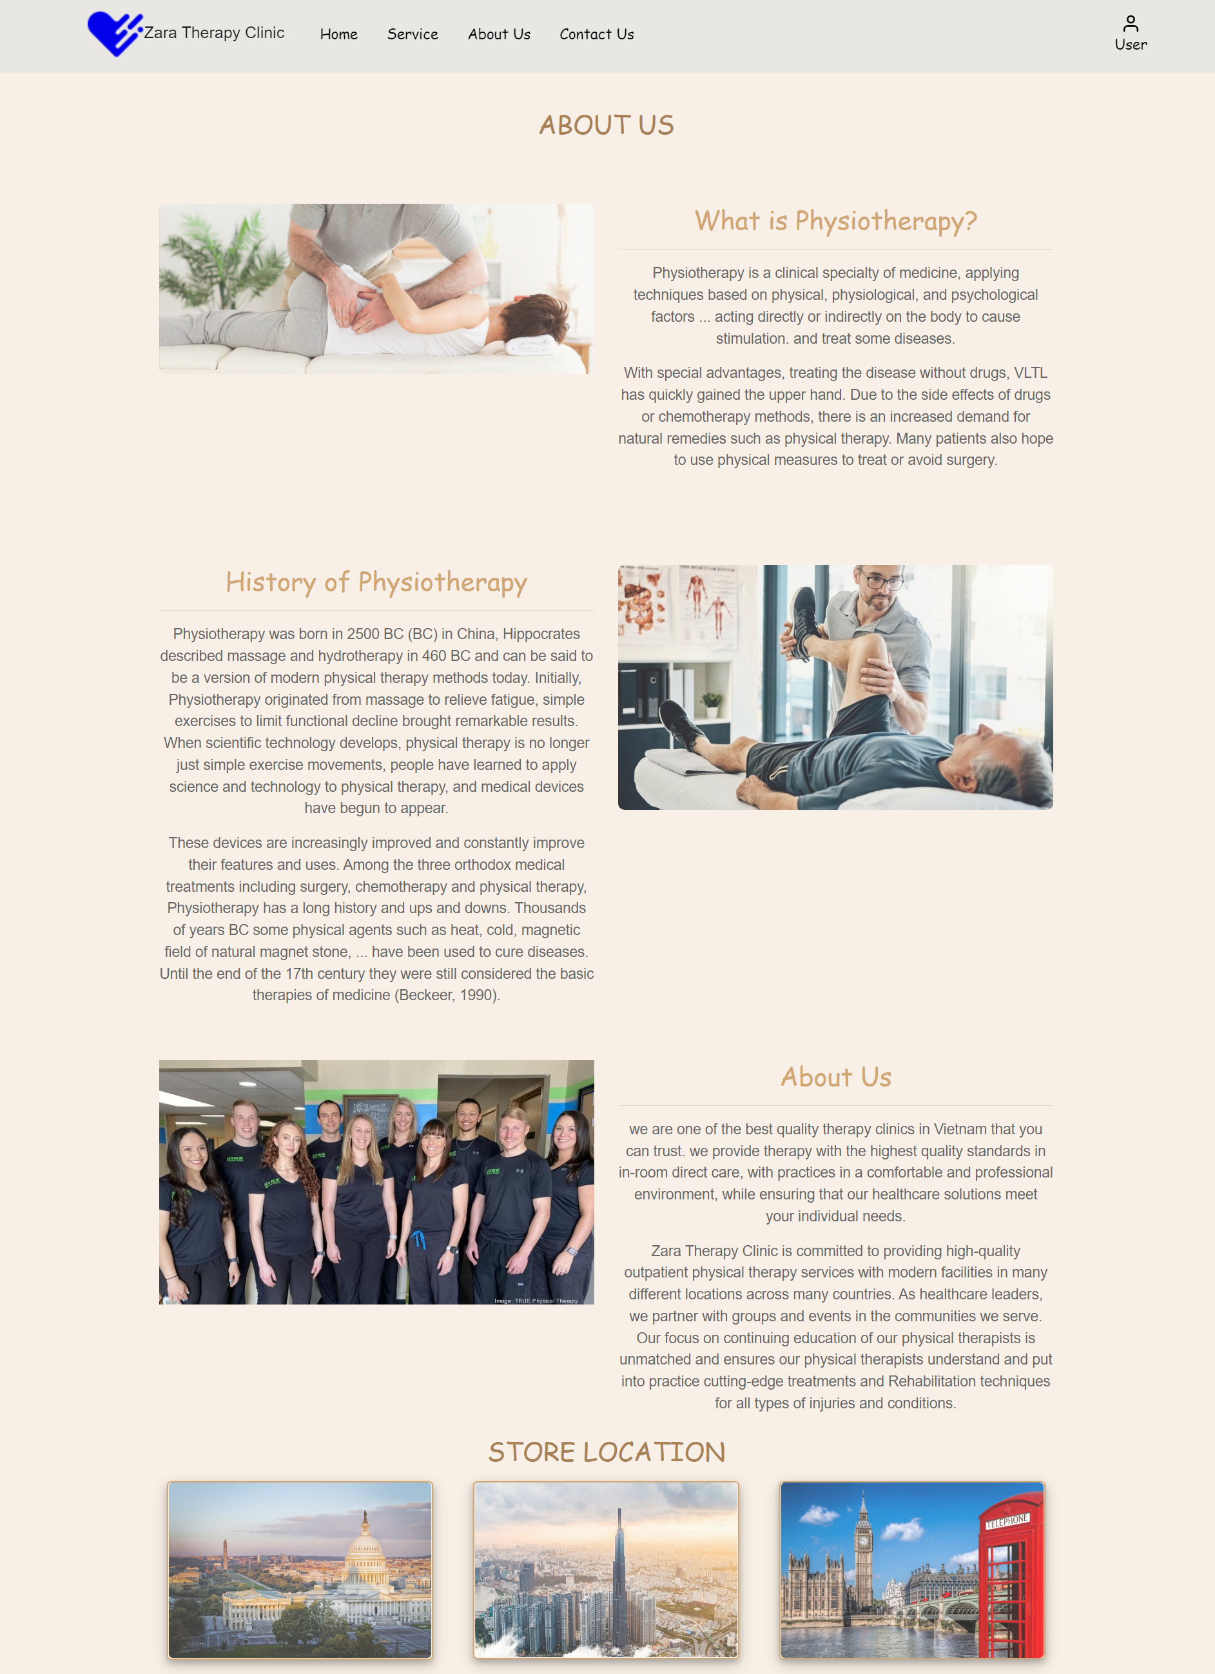

**III: ContactUS** 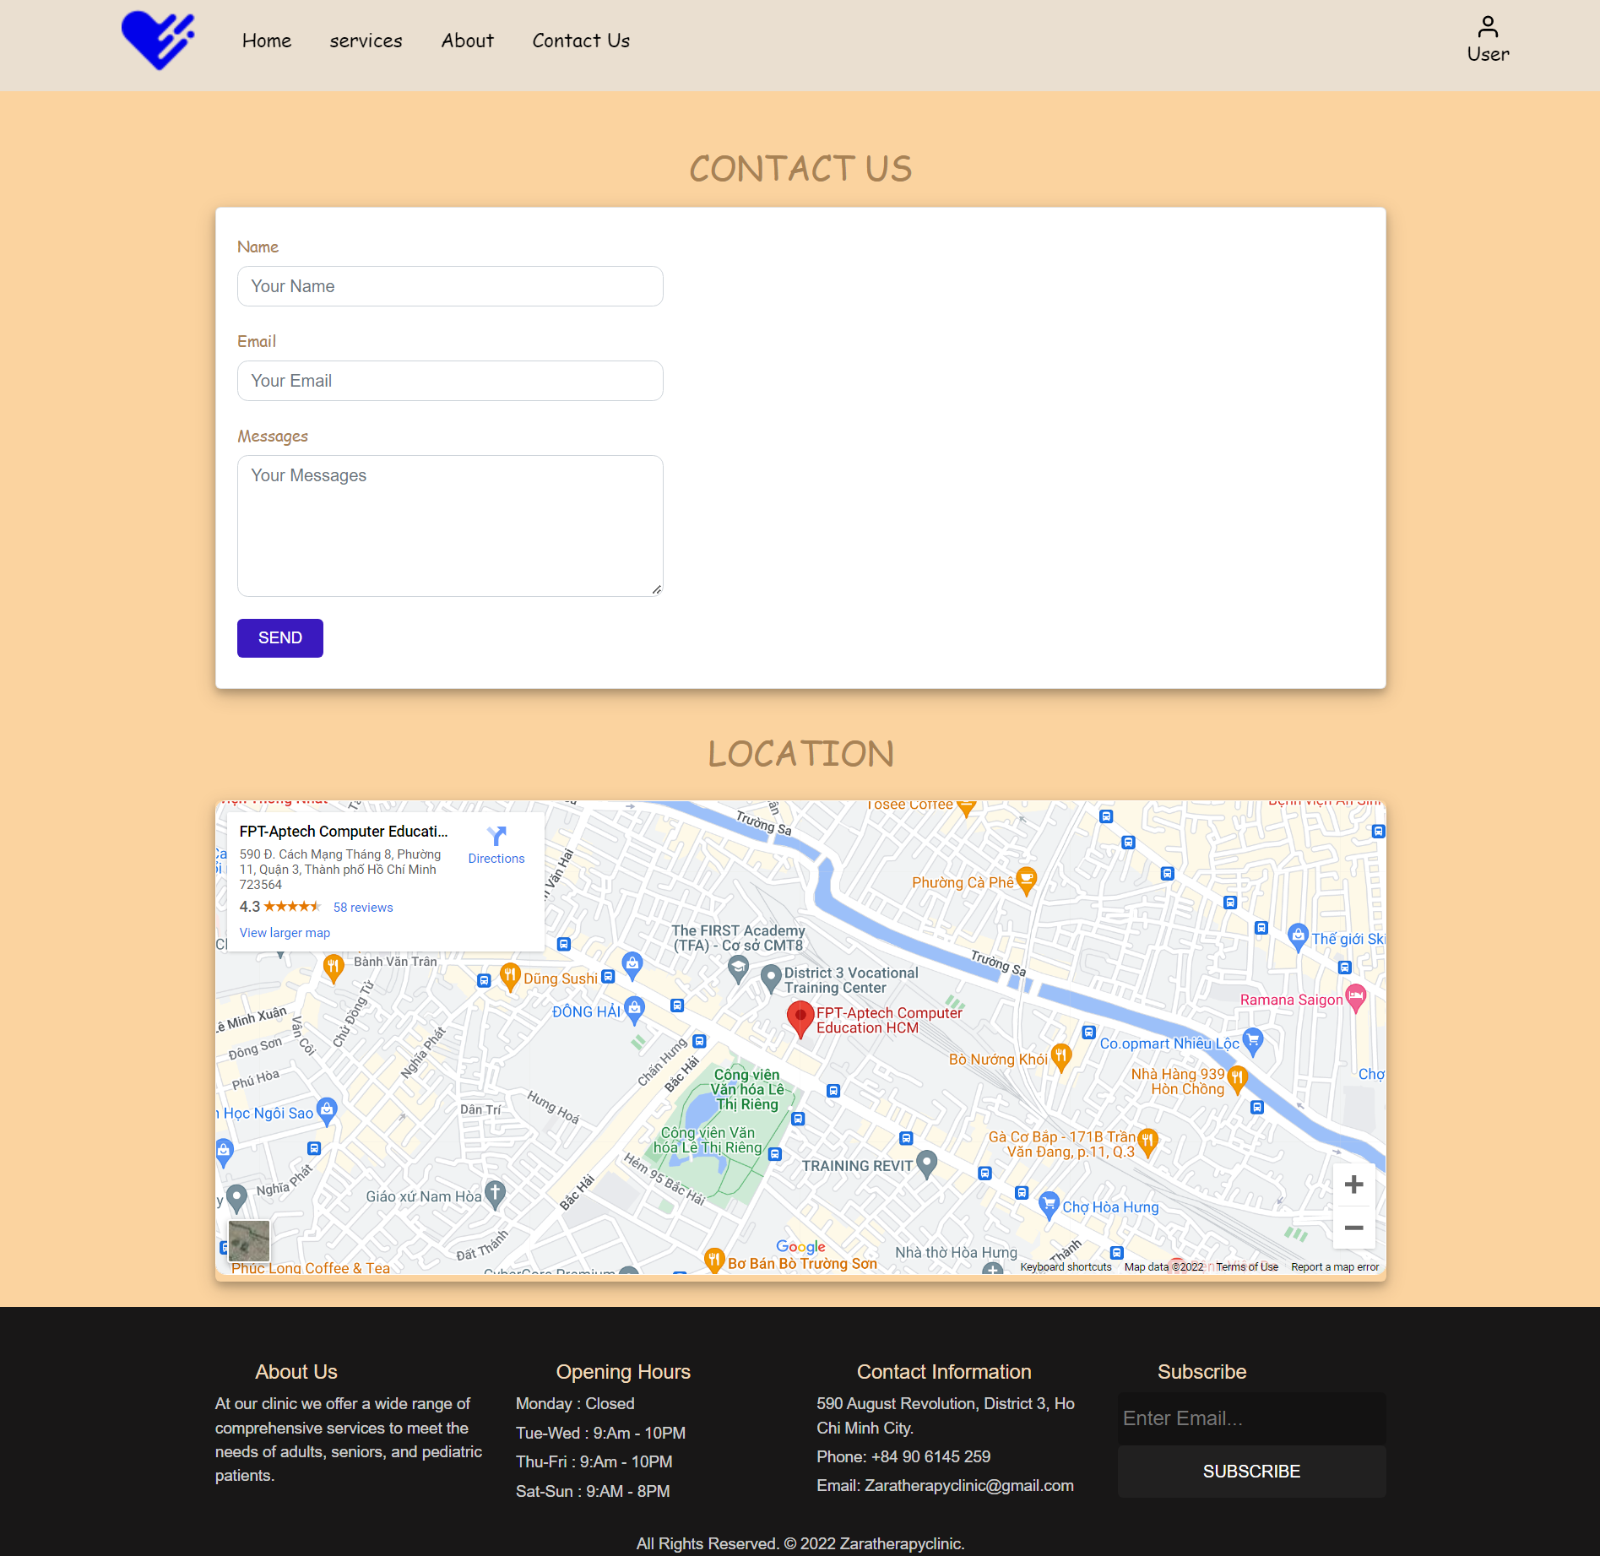

**IV: Login**

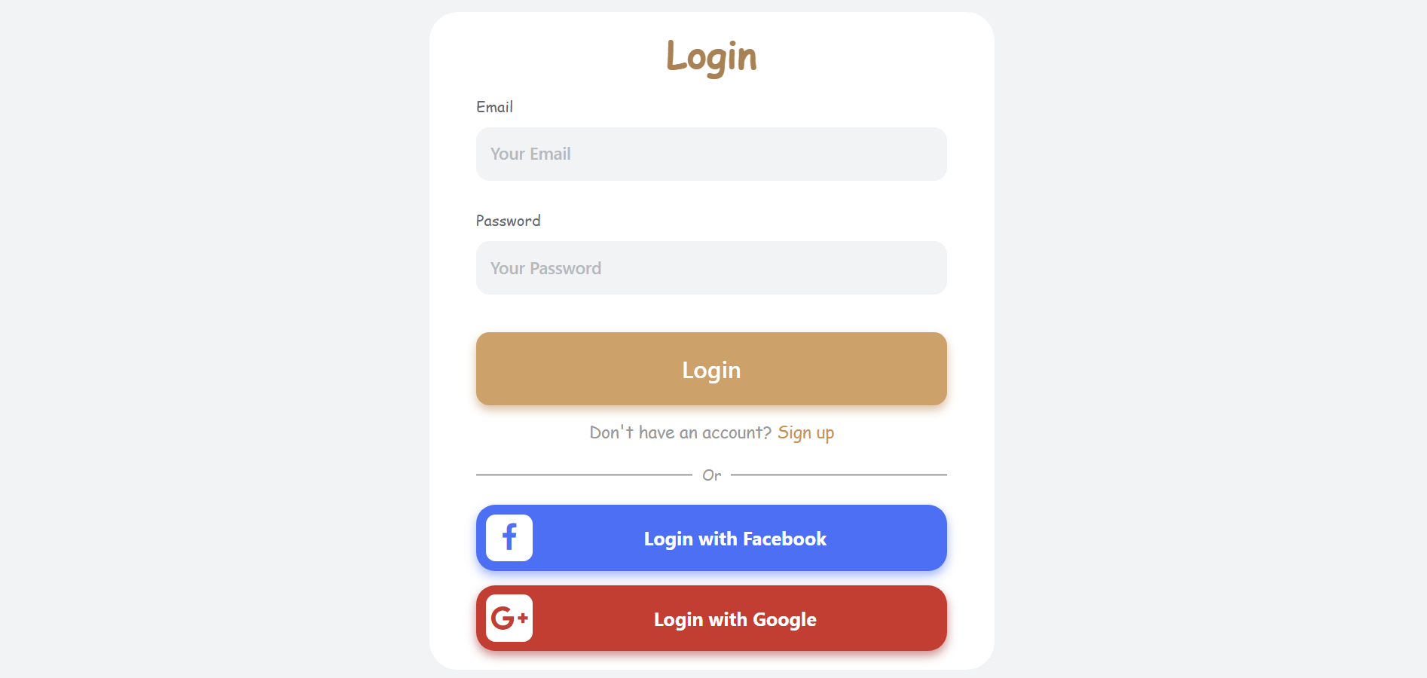

**V: SignUP**

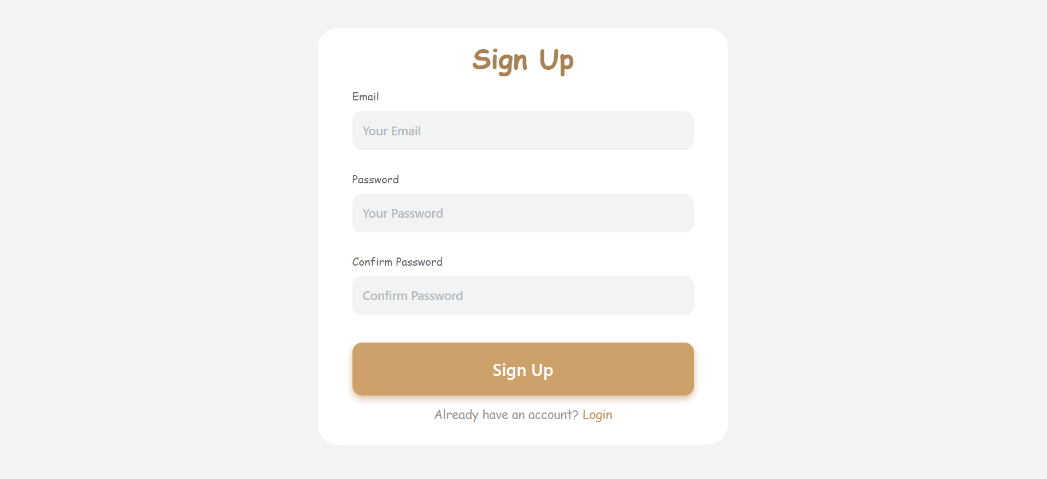

|  |  |  |  |  |
| --- | --- | --- | --- | --- |
| **Design Plan**:  Doodle New Search Tool | | **Document Name**: Testing document | **SWD/Form** No.06/TD/Ver1.0 | |
| **Effective Date**:01-01-2002 | | **Version** 1.0 | **Page No**: **9** of **17** | |
| **Design Plan**:  Doodle New Search Tool | | **Document Name**: Final checklist | **SWD/Form** No.07/FC/Ver1.0 | |
| **Effective Date**:01-01-2002 | | **Version** 1.0 | **Page No**: **10** of **17** | |
|  | **Testing document** | | |  |

|  |  |  |
| --- | --- | --- |
| **Sr.No** | **Features Tested** | **Remarks** |
| 1 |  |  |
| 2 |  |  |
| 3 |  |  |
| 4 |  |  |
| 5 |  |  |
| 6 |  |  |
| 7 |  |  |
| 8 |  |  |
| 9 |  |  |
| 10 |  |  |
| 11 |  |  |
| 12 |  |  |
| 13 |  |  |
| 14 |  |  |
| 15 |  |  |

## Final checklist

|  |  |  |
| --- | --- | --- |
| **Sr.No** | **Aspected Tested** | **Suggestion/**  **Remarks** |

|  |  |  |
| --- | --- | --- |
| 1 | Are all the users able to view the images and links? | Yes |
| 2 | Have all the views, modules and controllers been properly  integrated and is the site function as a single page application? | No |
| 3 | Are the GUI content devoid of spelling mistakes? | No |
| 4 | Is the application user-friendly? | Yes |
| 5 | Is the Website launching correctly in all popular browsers? | Yes |
| 6 | Are all the forms validated with proper criteria? | Yes |
| 7 | Do all text links lead to the appropriate website? | yes |
| 8 | Do all image links lead to the appropriate website? | No |
| 9 | Are all the images and links clearly visible on the page? | Yes |
| 10 | Does the Web page work properly in all the tested browsers? | Yes |
| 11 | Does the Web page take too long to be loaded fully? | No |
| 12 | Is the navigation sequences correct through all the Web pages on the site? | Yes |
| 13 |  |  |

|  |  |  |
| --- | --- | --- |
|  | Is the JavaScript code working as expected in all click events? |  |
|  |  |  |
|  | (Sinh viên ghi thêm…) |  |

|  |  |  |
| --- | --- | --- |
| **Design Plan**:  Doodle New Search Tool | **Document Name**: Task Sheet | **SWD/Form** No.08/TS/Ver1.0 |
| **Effective Date**:01-01-2002 | **Version** 1.0 | **Page No**: **11** of **17** |

|  |  |  |  |  |  |  |  |  |  |
| --- | --- | --- | --- | --- | --- | --- | --- | --- | --- |
| **No** | | **Member** | **Contents** | | **Page Name** | **Activity Plan** | **Date of Preparation of Activity Plan** | | |
| **Planed Start Date** | **Actual Start Date** | **Actual Days** | **Status** |
| 1 | | Nguyễn Thành Trung | Hompage Login | | Hompage.html | 13-12-2022 | 14-12-2022 | 2 | OK |
| 2 | | Login.html | 13-12-2022 | 14-12-2022 | 2 | OK |
|  | | | | | | | | | |
| 1 | | Nguyễn Hoàng Thiên Ân | ContactUs Products | | Products.html | 13-12-2022 | 14-12-2022 | 2 | OK |
| 2 | | ContactUs.html | 13-12-2022 | 14-12-2022 | 2 | OK |
|  | | | | | | | | | |
| 1 | | Nguyễn Hữu Duy Khang | Service Search | | Service.html | 13-12-2022 | 14-12-2022 | 2 | OK |
| 2 | | Search.html | 13-12-2022 | 14-12-2022 | 2 | OK |
|  |  | | | | | | | | |
|  | 1 | Nguyễn Nam Khánh | | AboutUS Register | Aboutus.html | 13-12-2022 | 14-12-2022 | 2 | OK |
|  | 2 | Register.html | 13-12-2022 | 14-12-2022 | 2 | OK |

|  |  |  |
| --- | --- | --- |
|  | **Prepared by (Student)** | **Approved by (Faculty)** |
|  | **Project Group No**: 01 |  |
| **Signature** |  |  |
| **Date** |  |  |